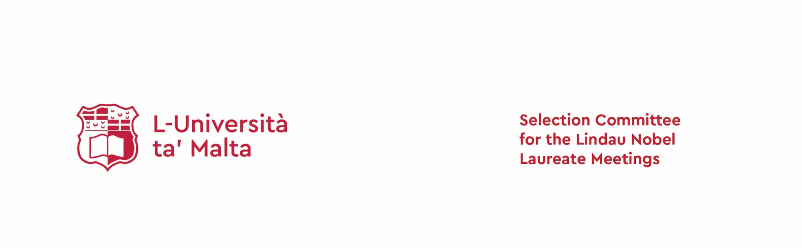

75th Lindau Nobel Laureates Meeting
  - Dedicated to Meeting on Interdisciplinary research
  - 28 June – 3 July 2026

APPLICATION FORM
NOTE:
- Before applying please review the application guidelines and eligibility criteria listed at the website: www.um.edu.mt/about/lindaunobellaureate/applynow
- Applications will not normally be accepted for researchers who (1) will be older than 35 years at the time of the meeting, (2) have held a resident academic position for more than one year or (3) have participated in a previous Lindau Nobel Laureates Meeting.
- The ideal applicants will be required to demonstrate an ability to promote science and to be worthy candidates who can promote the UM’s and Malta’s standing among the international scientific community.

Applicant details
Title | First name | Surname

Applicant’s area of specialisation (maximum of five words)

Organisation
Department
Full postal address
Email address
Gender | Male Female Other: Prefer not to state
Phone number

Date of birth
Place of birth

Early Career Researcher status
Note: Selection will favour students currently undertaking doctoral studies or postdoctoral fellows
Please select one and complete relevant details:
Yes / No | Applicant is enrolled in a research higher degree* at the University of Malta
Faculty (department)/Institute
Degree title
Thesis title
Date of commencement
Expected date of completion
Yes / No | Applicant has completed a research higher degree* and is currently working in the public or private sector but will continue to satisfy the eligibility criteria at the date of the Lindau meeting
Institution
Degree title
Thesis title
Date of conferment
Current employer
Position held
Date of commencement of employment
*Master of Philosophy (MPhil), Doctor of Philosophy (PhD) or a Postdoctoral Fellowship.

Please list recognised distinctions received, including awards for extra-curricular activities
Add extra lines as necessary
Date of award | Award name | Institute / organisation | Award description

Please list current and past tutoring experience
Add extra lines as necessary
Start and end date | Institute / organisation | Subject | Description

Please answer the below questions in the boxes provided.
Note: 1000 characters (including spaces) maximum per answer

Explain the motivation behind your study and / or research. What about this sets you apart from other applicants?

How will attending the meeting contribute to your career?

Describe your relationship with the University of Malta and any experience you may have had in public engagement with science.

If selected for this award, describe briefly how you would use this opportunity to engage citizens and other stakeholders with science.

Attachments
Please attach the following documents:
- Curriculum vitae
- Recent publication list, including conference presentations
- Letter of recommendation (maximum two) which is to be sent directly to the Selection Committee for the Lindau Nobel Laureate Meetings at lindau.committee@um.edu.mt

Important notices
All below conditions are agreed to by the applicant by submitting the signed application form.
- Nominations will be considered by the University of Malta’s Selection Committee for the Lindau Nobel Laureates Meetings which will recommend an applicant to the Council for Lindau Nobel Laureates Meetings. The final decision regarding attendance at the 75th Lindau Nobel Laureates Meeting will be made by the Council for Lindau Nobel Laureates Meetings. There is no possibility to appeal this final decision.
- The nominee that is selected by the University of Malta will be awarded funds for registration, travel and subsistence, provided that they are accepted by the Council for the Lindau Nobel Laureates Meetings.
- The successful delegate is expected to raise awareness locally about their attendance at the 75th Lindau Nobel Laureates Meeting in the media and to the general public, in accordance with the guidelines.
- All successful delegates are expected to attend the full program of events at the 75th Lindau Nobel Laureates Meeting. Delegates will need to arrive in Lindau before the opening ceremony on Sunday 28 June 2026 and depart after the close of the program on Friday 3 July 2026.

Please insert electronic signatures below:
Signature of applicant:
Name:
Date:

Submit your nomination forms and all supporting documents to lindau.committee@um.edu.mt
Deadline for nominations: Friday 24 October 2025, 17:00
For enquiries contact lindau.committee@um.edu.mt

