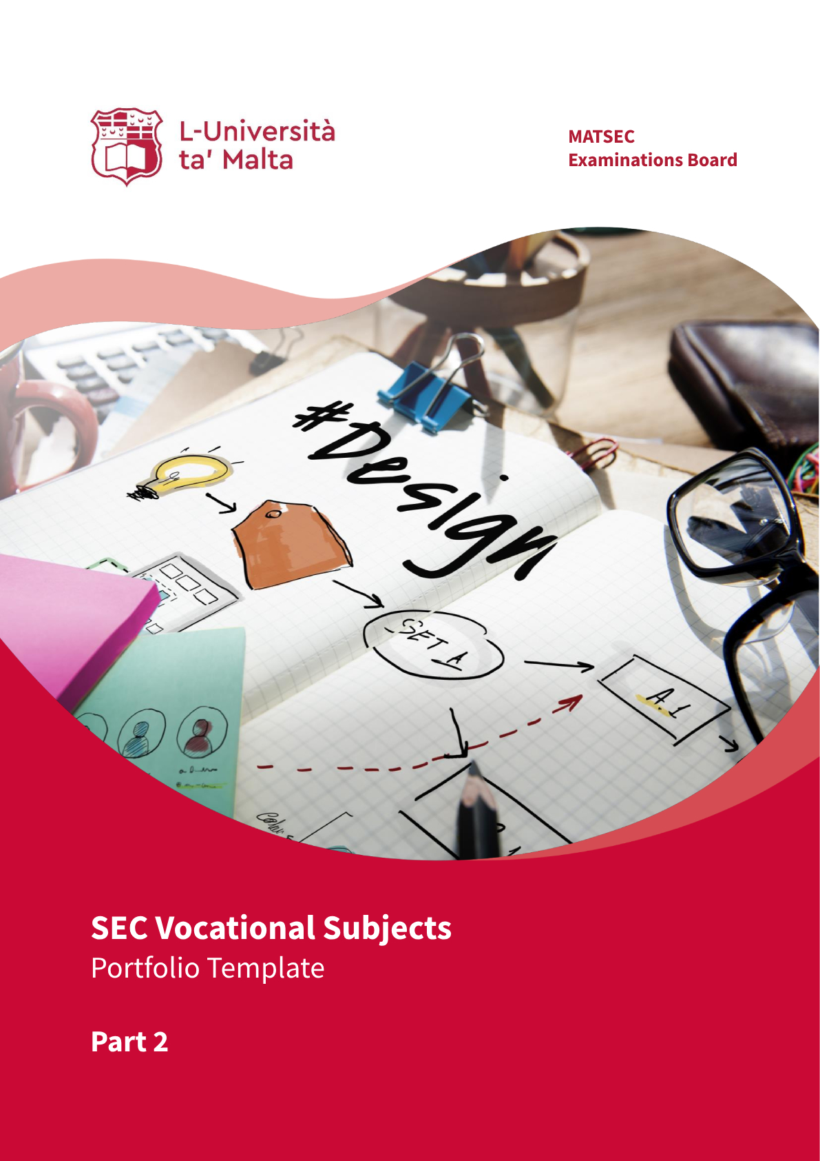

Introduction
This template is intended to guide students in compiling Part 2 of their Portfolio (coursework) for SEC Vocational Subjects, as per Scheme of Assessment indicated within each respective syllabus.
The design of this template is suggested in terms of structure and content order. If students choose to customise this document further or even create their own, they should ensure that the main elements, such as the subject details, personal details, the authenticity statement, section titles, and the marking scheme, are still included and presented in the same order.
‘Points for consideration’ have been included underneath each section. These points are not meant to be a strictly exhaustive list of aspects or questions, but should act as a general guidance for students in developing the content. Hence, they are to be interpreted as prompts in assisting students to think and reflect when preparing the necessary material in line with the section requirements. These points are to be deleted when presenting the actual work.
Students are reminded that they may be called by MATSEC for an interview in relation to their Portfolio.

Validity Period
This template is to be used by students who will be registering for the SEC Main Session 2027 onwards (hence cohorts commencing their Year 9 studies in 2024 and thereafter), unless otherwise communicated by MATSEC.
CHOOSE SUBJECT
Candidate Name
Candidate ID/Passport Number
Date of Submission

TABLE OF CONTENTS

AUTHENTICITY STATEMENT
I, the undersigned, declare that all the work being submitted is my own.

I further certify that where I made use of ideas, words, or passages from existing sources – if any – I paraphrased or quoted them using a proper referencing system.

I am aware that should I submit work which is not mine, or work which has been copied from one or more sources, I will be penalised as per MATSEC Examinations Board policies.

Student’s Signature: ______________________________________

APPLICATION CRITERION 1 | Select Criterion

SECTION 1 | OVERVIEW OF THE APPLICATION PROCESS | 
SECTION 1 | A description of the step-by-step process required to complete the application criterion including photo evidence of the main steps and of the final work/artifact

Points for Consideration:
- Ideally start by referring to what the actual criterion was about.
- Provide the steps in a logical order.
- Make sure that the necessary details required to describe the process are included.
- Support the process description with photo evidence of the process and the final work/artifact.
  - Depending on the application criteria chosen, scanned diagrams, sketches, screenshots, or other forms of still images may be acceptable too.
- Ensure that the images provided are clear.
- Include captions with the provided evidence so that you can easily refer to them when describing the process.
- You may include the evidence within the text or separately at the end of the description.
- Use as much space as you need.

SECTION 2 | OVERVIEW OF SKILLS | 
SECTION 2 | An explanation of the main skills employed in carrying out the application criterion

Points for Consideration:
- Include the main underlying skills you needed in order to be able to carry out the application criterion.
  - Before starting, spend some time to think of these skills (including any necessary knowledge and training required).
  - You may also include any strengths, weaknesses or challenges met in applying these skills. Try to reflect and reason things out:
    - Why were these skills so important?
    - How did these skills make it possible for you to carry out the work properly?
    - What happened (or could happen) if such skills were not properly mastered?
- Make sure that you provide the necessary details to explain why these skills were required and/or applied.
- Use as much space as you need.

APPLICATION CRITERION 2 | Select Criterion

SECTION 1 | OVERVIEW OF THE APPLICATION PROCESS
SECTION 1 | A description of the step-by-step process required to complete the application criterion including photo evidence of the main steps and of the final work/artifact

Points for Consideration:
- Ideally start by referring to what the actual criterion was about.
- Provide the steps in a logical order.
- Make sure that the necessary details required to describe the process are included.
- Support the process description with photo evidence of the process and the final work/artifact.
  - Depending on the application criteria chosen, scanned diagrams, sketches, screenshots, or other forms of still images may be acceptable too.
- Ensure that the images provided are clear.
- Include captions with the provided evidence so that you can easily refer to them when describing the process.
- You may include the evidence within the text or separately at the end of the description.
- Use as much space as you need.

SECTION 2 | OVERVIEW OF SKILLS
SECTION 2 | An explanation of the main skills employed in carrying out the application criterion

Points for Consideration:
- Include the main underlying skills you needed in order to be able to carry out the application criterion.
  - Before starting, spend some time to think of these skills (including any necessary knowledge and training required).
  - You may also include any strengths, weaknesses or challenges met in applying these skills. Try to reflect and reason things out:
    - Why were these skills so important?
    - How did these skills make it possible for you to carry out the work properly?
    - What happened (or could happen) if such skills were not properly mastered?
- Make sure that you provide the necessary details to explain why these skills were required and/or applied.
- Use as much space as you need.

Marking Scheme (for Assessor’s use only)

