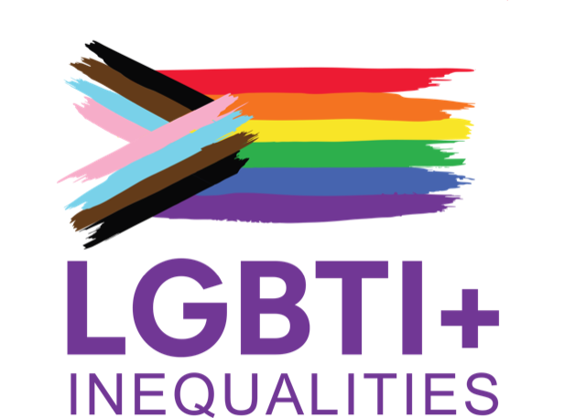
EU COST Action LGBTI+ Social and Economic (In)Equalities (CA19103)

LGBTI+ People at the Workplace. Bridging the gaps between academia, employers, employees, trade unions, civil society, institutions and policymakers
11-12 September 2023
University of Malta, Valletta Campus
Valletta, Malta

DAY 1: MONDAY 11TH SEPTEMBER

08:30 - 09:00 Welcome and registration

09:00 - 09:30 Introduction to the COST Action and the Stakeholders Meeting.
Anna Einarsdottir, J. Ignacio Pichardo and Ruth Baldacchino

Host Institution Welcome: Claire Azzopardi Lane - Faculty for Social Wellbeing, University of Malta

09:30 - 10:00 Who’s in the room?

10:00 - 11:00 Panel Discussion: Setting the context: LGBTI+ people & the workplace in Europe 2023
Introduction and Moderation: Anna Einarsdottir (University of York)
Speakers:
- Sandro Gallittu, New Rights unit - CGIL Trade Union (Italy)
- Gabriella Calleja, Council of Europe - Sexual Orientation and Gender Identity (SOGI) Unit
- Aisling Reidy, ILGA-Europe

11:00 - 11:30 Break

11:30 - 13:00 Small Groups work: What are the challenges and gaps?
Moderator: Beata Bielska (Nicolaus Copernicus University)

13:00 - 13:15 Plenary: Report back from workshops

13:15 - 14:30 Lunch

14:30 - 15:45 Panel Discussion: What are companies, institutions and governments doing?
Introduction and moderation: J. Ignacio Pichardo (Universidad Complutense de Madrid)
Speakers:
- (speaker tbc) FRA or European Commission
- Christophe Margaine, L’Autre Cercle / Odyssey for Equality
- Clayton Mercieca, Human Rights Directorate, Malta

15:45 - 16:15 Break

16:15 - 17:45 Small Groups work - What are the best practices and opportunities? How can we exchange and get to know the data, best practices and resources?
Moderator: Liam Cini O’Dwyer (King’s College London)

17:45 - 18:00 Plenary: Report back from workshop & Closing of Day 1

20:00 Evening reception for networking

DAY 2: TUESDAY 12TH SEPTEMBER

09:00 - 10:30 Small Groups work - How do we collaborate and work together? How can academia, stakeholders, trade unions, civil society organisations, institutions and governments collaborate to create a respectful workplace for LGBTIQ+ people? What kind of research and data do we need? How can this COST network contribute?
Moderator: Soledad Cutuli (Universidad Complutense de Madrid)

10:30 - 10:45 Plenary: report back from workshops

10:45 - 11:15 Break

11:15 - 12:30 Panel Discussion: Bridging the gaps between LGBTI+ civil society, academia, trade unions, institutions and companies
Introduction and moderation: Ruth Baldacchino (University College Dublin)
Speakers:
- Kristian Randelovic, XY Spectrum (Serbia)
- Lenny Emson, Transgender Europe
- Sabrina Sanchez, European Sex Workers Alliance
- Gurchaten Sandhu, ILGA World

12:30 - 13:00 Conclusions from Event Rapporteurs

