Student Placement Agreement Process TTC2240

Before you start your placement, it is essential that you have a signed Student Placement Agreement (SPA). You should not start your placement until you have a signed SPA in hand. Follow these important steps to complete the process:

- Choose Your Placement
  - Select your preferred company/organisation from the provided list.
  - Use the Google form to indicate your 1st, 2nd, and 3rd choices.

- Allocation and Interview
  - Your academic coordinator will allocate a placement to you. This does not guarantee you a placement.
  - Once you have been allocated a placement, you must send your CV and cover letter to the representative of the company/organisation which states your wish for a placement. Your academic coordinator will provide you with these details.
  - You may be asked to attend an interview. If you do not receive a response from the company/organisation, do not hesitate to send a follow up email. If you are unable to establish communication, reach out to your academic coordinator who will assist you.

- Signing the SPA
  - Once your placement is approved, the SPA must be signed by the company/organisation’s legal representative. Therefore you should access the SPA template which is available on VLE.
  - You should send the SPA to your mentor within the company/organisation with an explanation on who may sign this Agreement.
  - The SPA may only be signed by the Legal Representative of the company/organisation. This is non-negotiable and may not be signed by a director or manager. Should you require assistance in getting this done, please speak to the individual responsible for placement administration.
  - The SPA should be completed digitally, not handwritten, and your name should be included on the first page.
  - The Legal Representative is a responsible person listed on the Malta Business Registry. Here is an example -
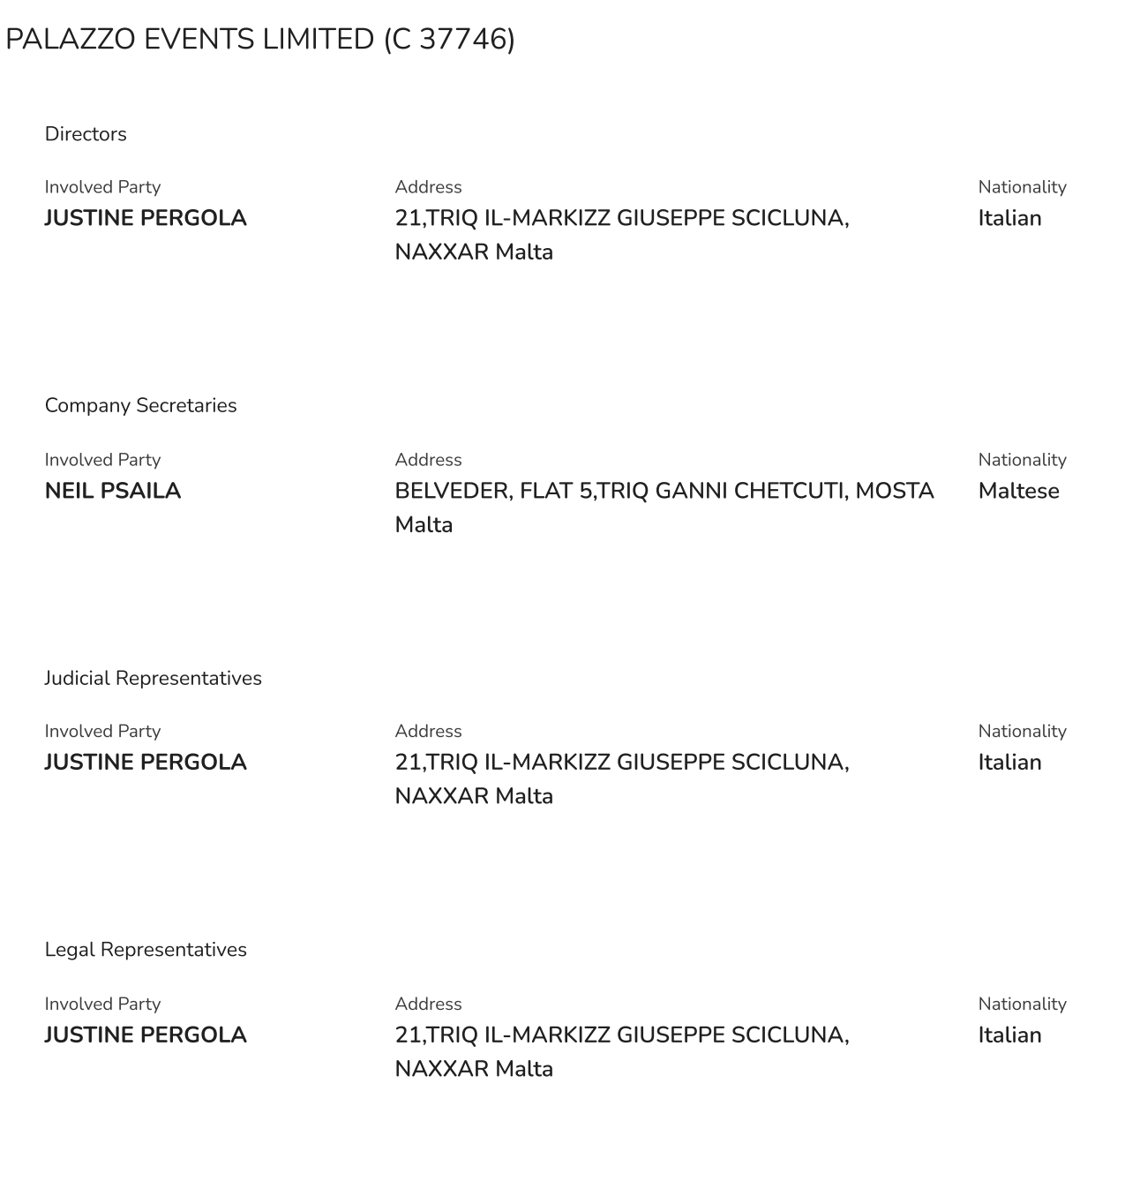

- Returning the SPA
  - After the company's legal representative signs the SPA, return it as a PDF to the department's placement coordinator.
  - They will review the SPA and forward it to the Legal Office for due diligence.

- University Signing
  - The approved SPA will then be signed by the Rector as the university’s legal representative. This process should take no more than five working days.
  - Once the Rector has signed the SPA, it will be returned to you.

- Final Steps
  - Send a copy of the signed SPA to the relevant person in your company/organisation.
  - You may begin your placement only when you have a signed SPA from both legal representatives.

Additional points
- If you have a specific company/organisation that you would like to carry out your placement at, you may contact your academic coordinator and seek approval from them. This must be done in writing, where you provide a brief description of your expected tasks and outcomes.

- If you are currently working at a company/organisation that is willing to provide you with a placement, you may conduct your placement there as long as you have sought the approval of your academic coordinator. This must be done in writing, where you provide a brief description of your expected tasks and outcomes. You will still be required to provide a signed SPA even if you have an employment contract with the company/organisation.

