Word Template for FYP Dissertations (Replace with your title,
Style: Dissertation Title)
Name & Surname (Style: Name and Surname)
Supervisor: Name & Surname
Co-Supervisor: Name & Surname – if one was appointed
(Style: Dissertation Title Sub Text
You need to press CTRL-TAB to insert a tab here)

June 2023 (Style: Dissertation Title Sub Text)
Submitted in partial fulfilment of the requirements
for the degree of ‘insert name of course here’ (Style: Partial Fulfilment Text)


Abstract (Style: Headings)
This document contains a template for final year project dissertations. Several Word styles are defined that determine the layout and fonts to be used in the document. It also gives instructions how to use this template and how to write your dissertation. Read this carefully before starting to write your dissertation.
This is a summary of the dissertation. It must be less than 300 words long and fit in one page. It should give enough information to allow a potential reader to decide whether or not the whole report will be of interest to them. It should briefly describe the main features of the work done including the aims and conclusions, brief overview of the results obtained and a critical statement of the success of the approach. It should be both self-contained and self-explanatory.
Acknowledgements
This section should be used to record any debt for the use of facilities or help from particular sources. You should mention any organisations that have helped fund the project. Also, for placement students, it would be diplomatic to include the name of the supervisor in the host organisation where the student was placed and any of his or her colleagues who helped you.
Contents
Abstract (Style: Headings) ii
Acknowledgements iii
Contents iv
List of Figures vi
List of Tables vii
List of Abbreviations viii
1 Introduction (Style: Heading 1) 1
1.1 How to Use this Template (Style: Heading 2) 1
1.2 Using Styles 1
1.3 Line Spacing for Headings 3
1.4 Inserting Equations 4
1.5 Automatically updating of Cross-Referencing 5
1.5.1 Using Styles Correctly (Style: Heading 3) 5
1.5.1.1 Sub-Titles (Style: Heading 4) 6
1.6 Some Hints on the Dissertation Writing Style 6
1.7 Some Hints on using Word 7
1.8 Avoiding Plagiarism 9
1.9 How to Write the Introduction 10
2 Background and Literature Review 11
2.1 References 11
2.1.1 RefWorks 11
2.1.2 Formatting the Reference Section 14
2.1.3 Examples of Different Types of References 16
2.2 Writing the Background and Literature Review Chapter 17
3 Specification and Design 18
3.1 Further use of Captions 18
3.1.1 Tables 18
3.1.2 Lemmas, Theorems, Corollaries etc. 19
3.2 Chapter Headers 21
3.3 Printing the Dissertation on Both Sides 22
3.4 Writing the Specification and Design Chapter 24
4 Implementation 26
4.1 Writing the Implementation Chapter 26
5 Testing and/or Evaluation 27
5.1 Writing the Evaluation and/or Evaluation Chapter 27
6 Future Work 28
6.1 Writing the Future Work Chapter 28
7 Conclusions 29
7.1 Writing the Conclusions Chapter 29
References 30
Bibliography 31
Appendix A When to Use Appendices (Style: Appendix Heading 1) 32
A.1 Appendices Headings (Style: Appendix Heading 2) 32
A.1.1 Appendix Sub-Headings (Style: Appendix Heading 3) 32
A.2 What to put in Appendices 32
Appendix B Version Information 33
B.1 Copyright Information 33
B.2 Suggestions 33

List of Figures
Figure 1.1 Cross-referencing (Style: Caption Figure). 2
Figure 1.2 Inserting a caption to a figure. 3
Figure 1.3 Figure example, a rectangle and a triangle. 7
Figure 1.4 Keeping paragraphs or lines on the same page. 9
Figure 2.1 RefWorks Citation Manager settings options. 12
Figure 2.2 Inserting a citation using RefWorks. 13
Figure 2.3 Content Control Box containing the references. 14
Figure 2.4 Correctly formatting the Reference section. 15
Figure 3.1 Converting document to printing on both sides. 23
Figure 3.2 Inserting chapter headers. 24

List of Tables
Table 3.1 Simple table example. 18
Table 3.2 A more complicated table example. 19

List of Abbreviations
FYP Final year project (Style: Abbreviations)
GPS Global positioning system
ICT Information and Communication Technology
IOC International Olympic Commitee
Note that the List of Abbreviations should be sorted on the acronym list.
The entries in the List of Abbreviations should be assigned the Abbreviations style.

Introduction (Style: Heading 1)
As for the rest of the dissertation, the first paragraph in a new section should have the style Dissertation Body First Paragraph. This should be selected automatically when you start a new paragraph after a section heading. If not, select it manually from the Styles list.
For all subsequent paragraphs, the style chosen should be Dissertation Body. This should be selected automatically when you start a new paragraph after the first one. If not, select it manually from the Styles list. The first paragraph at the start of a new section is not indented, whereas all subsequent paragraphs should have the first line indented.
If your computer is missing the Lato font, you can download this from https://www.latofonts.com/lato-free-fonts/. Instructions how to install new fonts can be found on the page “Download and install custom fonts to use with Office” at https://support.microsoft.com/en-us/office/download-and-install-custom-fonts-to-use-with-office-0ee09e74-edc1-480c-81c2-5cf9537c70ce.

How to Use this Template (Style: Heading 2)
It is suggested that you make a copy of this template document, naming the new copy something relevant to your dissertation. Keep a copy of the original template, so that you can always refer back to the original document with the complete instructions.
The formatting of the template is already in the required style required by the Faculty of Information and Communication Technology (ICT). In some cases, you simply need to replace the text in the headers by your own text. In other cases, you need to replicate the format for your own use case. Make sure that once you are done writing your dissertation, you delete any remaining text from this template.

Using Styles
Make sure that you always select the correct style for each part of the dissertation and do not change any settings in these defined styles. You should only use manual font formatting for specific local changes, such as highlighting a word in bold.
In general, you should not insert extra carriage returns to separate paragraphs and other items on the page and should rely on the spacing provided by the defined styles.
Note that when using the heading styles Heading 1-4, the section number is automatically generated. Heading 1 is reserved for the chapter title and should be referred to within the text as indicated in the following example: Chapter 1 will give the literature review and the background. Note that the cross-reference to the chapter number should not be entered manually as a number. Instead, it should be entered by selecting the ribbon References and then in the Captions sections in the ribbon select Cross-reference. The dialog box shown in Figure 1.1 is then used to select the correct reference. For chapter and section referencing, the reference type selected should be Heading. The Insert reference to should be set to Heading number. Then select the correct heading to refer to and then click Insert.
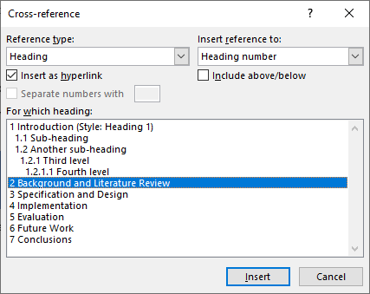
Figure 1.1 Cross-referencing (Style: Caption Figure).
References to sections other than Heading 1 (Chapters) should be referred to within the text as Sections, such as for example Section 1.5.1. Use Word’s automatic cross-referencing when referencing other items (Figures, Tables, Theorems, Lemmas etc.) as well (see Section 3.1).
When inserting figures, to correctly apply the correct layout, select the inserted figure object and then apply the style Figure. This will centre the figure on the page and sets the correct spacing before and after the figure.
To insert a figure caption, select the ribbon References, and then click the button Insert Caption. The dialog box shown on the left of Figure 1.2 is presented. For the Label, select Figure. The figure number should also include the chapter number, as shown in Figure 1.2. If the chapter number is missing, then click on the Numbering button and in the resultant dialog box, shown on the right of Figure 1.2, make sure that the Include chapter number tick box is selected and that the period is selected for the Use separator. Insert the caption by clicking on the OK button.
When a new caption is inserted, the caption is always automatically assigned by Word the style Caption. For figures you need to change this manually to the style Caption Figure.
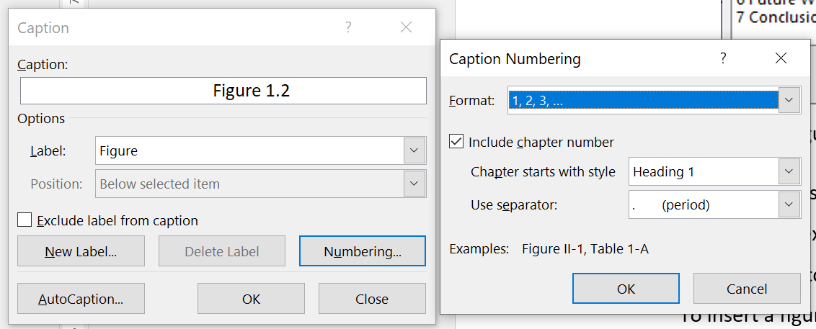
Figure 1.2 Inserting a caption to a figure.

Line Spacing for Headings
Notice that spacing before and after section headings are automatically set by the style and should not be modified. Do not manually insert extra space between the different items on the page.

Inserting Equations
When inserting an equation, proceed as follows (notice that the numbered list shown below is formatted with the style Numbered List).
- The first time that you need to insert an equation, select the table in the document containing the blank equation given in (1.2).
- Select the Insert ribbon.
- Then click on the down arrow under the Equation button in the ribbon.
- Click on Save Selection to Equation Gallery.
- For the Name field, insert Equation.
- Make sure that in Options, the option Insert content in its own paragraph is selected.
- Click on OK.
- Note that steps 1-7 are required only once. Once the equation format is saved to the gallery, you can safely delete the table containing the blank equation from the document.
- Each time you need to insert an equation, select the Insert ribbon and click on the down arrow under the Equation button in this ribbon.
- Scroll down in the list provided until you find the defined Equation set earlier in steps 1-7, and click on it. This will insert a blank equation together with an equation number. Simply click on the Type equation here to type in your equation using Word’s equation editor.
 | $$Type equation here.$$ | (1.1)
Note that when referring to an equation in the text, you only include the equation number (surrounded in brackets) without using the word “equation.” For example, (1.2) is a quadratic. Note also that when referencing an equation use Cross-reference (from the References ribbon), select Equation for the Reference type and under Insert reference to select Entire Caption before inserting the required reference. The equation object in (1.1) has been left blank so that you can save this as a template as indicated in steps 1-7 above.
∴ | $$y=x^{2}+2x+1$$ | (1.2)
When inserting an equation, a table with three columns is automatically inserted, as in (1.2). The first column may be left blank, or else, you may include some text here, like for example ∴, that precedes the equation. The equation is in the second column and is automatically centred on the page. Whereas the third column includes the equation number which is automatically generated and is right justified.
When referring to variables within an equation, it is best to type-in the same variables within the text itself using the equation editor as well. This will ensure that the same font type and style is used both in the equations and the body of the text for consistent use. So do not use x to refer to the variable in (1.2), but rather use $x$.

Automatically updating of Cross-Referencing
Although cross-referencing might feel like a cumbersome procedure, it will save you headaches and problems as you start editing your dissertation and moving things around or inserting new items. With cross-referencing, items will automatically be renumbered, and corresponding cross-references updated without any intervention from your end.
To force Word to automatically update the cross-referencing, select the entire document by pressing CTRL-A on your keyboard, followed by F9. Note that following this procedure, you may be asked to update the various tables of contents as well. It is always a good idea to force updating of cross-referencing using the above procedure, before printing the document.

Using Styles Correctly (Style: Heading 3)
Using styles correctly will ensure consistent formatting of your dissertation and will also ensure adherence to the Faculty’s requirements. It also gives a professional look to your write-up.
It is also important to use consistent capitalisation in the section titles. It is recommended to capitalise each word in the title, except when using articles (a, an, the), coordinating conjunctions (and, but, for) and prepositions (at, by, to, etc.) unless these are the first word in the title.

Sub-Titles (Style: Heading 4)
Although a fourth level of sub-heading is available, you should be careful when to use it. Do not put text in sub-headings unnecessarily.
When using the Numbered List style, numbering will continue from a previous list (if any). To change this, simply right click on the first number in the list and select Restart at 1.
- First item.
- Second Item.
- Third item.

Some Hints on the Dissertation Writing Style
Here are some do’s and do not’s when writing the dissertation.
- Do not use contractions. For example, write “do not” not “don’t.” Write “would not” not “won’t” etc.
- Avoid using the first person. For example, do not write, “I performed the following experiments.” Instead write “The following experiments were performed.”
- Always follow a full-stop at the end of a sentence by two (not one) spaces.
- Always perform a spelling check before submitting your dissertation. Typos give the impression that you were careless in your write-up, which will not score well with the examiners.
- Always proofread your dissertation. You can either do this yourself or get a friend or a family member to do this for you. Never submit a dissertation after a typing round without this check. Missing words, misplaced words and other similar errors (which will not be picked up by a spell checker) will again give an impression of carelessness.
- Use British English throughout your dissertation, e.g., do not use “color” but rather “colour.”
- Do not write small numbers or round values (e.g., a thousand) using numeric literals within the text, instead write these using words. So do not write “2 examples”, instead write “two examples.”
- When using abbreviations and acronyms, always make sure that you first define these before first use. You do this by defining the term in full followed by the abbreviation or acronym in brackets. The full term should only be capitalised if it is a proper noun (e.g., the name of an organisation). For example, the headquarters of the International Olympic Committee (IOC) is based in Lausanne, Switzerland. Otherwise, do not capitalise the words in the term, e.g., the global positioning system (GPS) is very useful when travelling. Abbreviations and acronyms used should be listed in the List of Abbreviations. Only introduce an acronym if you are going to use the term more than three times in your dissertation, otherwise use the term in full.
- Be consistent in the use of variable names, i.e., always use the same variable name for the same quantity. Do not use the same variable name for different quantities. You have to be particularly careful when quoting equations from literature. In this case you need to change variable names, if required, to make equations consistent with your notation (and not the notation used in the cited paper).
- It is important that any figures used in the dissertation should be referred to and explained within the body of the text. Never put a figure without referring to it (such as Figure 1.3). Also make sure that captions for figures and tables clearly explain, in a succinct manner, what the item is showing.

Figure 1.3 Figure example, a rectangle and a triangle.

Some Hints on using Word
The following are some hints on how to optimise your use of Word.
- If you wish two words to remain on the same line next to each other use a hard space instead of a normal space. In Word you insert a hard space by pressing CTRL-SHIFT-Space Bar.
- If you wish to keep two paragraphs on the same page, select the first paragraph and in the Home ribbon, expand the Paragraph section. In the resultant dialog box, select the Line and Page Breaks tab, as shown in Figure 1.4. Then tick the check-box next to Keep with next and click OK. You can also tick the check-box next to Keep lines together, if instead you need to keep the selected lines together on the same page.
- Use keyboard shortcuts to access frequently used styles and other Word functions. Some keyboard shortcuts are already pre-defined in Word. You can modify these and define others yourself. For more information refer to the webpage on how to “Customize keyboard shortcuts” at: https://support.microsoft.com/en-us/office/customize-keyboard-shortcuts-9a92343e-a781-4d5a-92f1-0f32e3ba5b4d#:~:text=Use%20a%20mouse%20to%20assign,the%20keyboard%20shortcut%20changes%20in.
- You can automate repetitive tasks by recording a macro. Further information how this is achieved can be found by referring to the webpage “Create or run a macro” at https://support.microsoft.com/en-us/office/create-or-run-a-macro-c6b99036-905c-49a6-818a-dfb98b7c3c9c.
- It is recommended to save your document often. Ideally you should enable the autosave feature in Word.
- If you save your dissertation on OneDrive, previous versions of the document are automatically saved for you whenever you save your document. This will enable to revert back to a previous version should you wish to do so.
- If you click on the Page information on the status bar at the bottom of the screen you will enable the navigation pane on the left of the window. This way you can navigate your document in an easier manner.
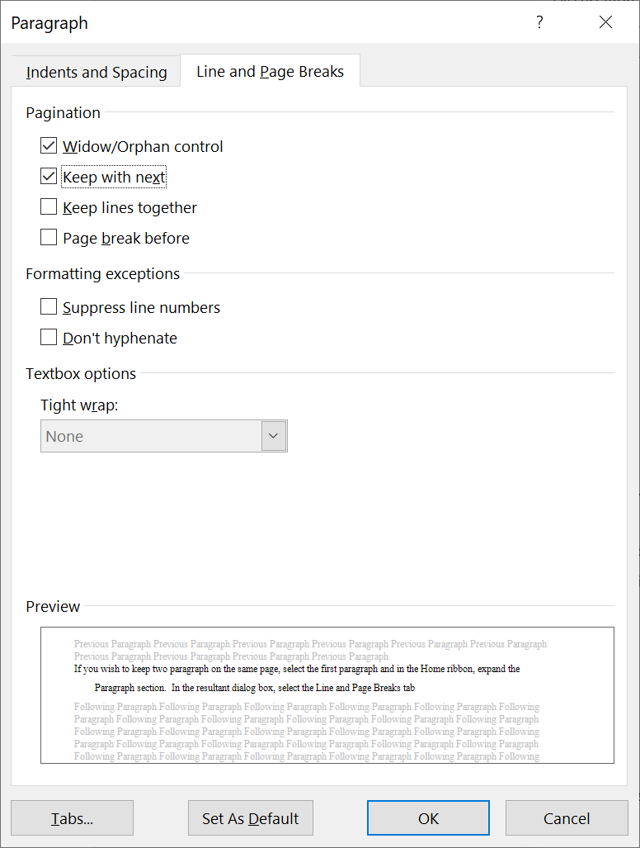
Figure 1.4 Keeping paragraphs or lines on the same page.

Avoiding Plagiarism
The dissertation is most probable the most significant piece of writing that you will undertake in your degree programme. It is therefore especially important to pay particular attention as to how avoid plagiarism. Always refer to the University’s guidelines on plagiarism [1]. The background and literature review chapter is particularly prone for plagiarised sections. Always paraphrase in your own words when you are referring to other work and make sure that you properly cite the work (see Section 2.1). If you need to quote a particular text segment, make sure that you put this between quotation marks, again clearly citing the source of the quotation. If the quoted text is short (only a few words), then you can include this in-line with your text. However, if this is longer, a sentence or more, then put the quotation in a separate paragraph, using the Quotation style, as shown in the following example. Cockrum et al. [2] assert that:
“Most engineering students learn by seeing examples of solved problems. This style is generally known as visual learning techniques.”
Other guidelines as to how to use this template may be found in Chapters 2 and 3.

Appendices
Always specify what material is included in the appendices, if any, within the body of the dissertation. You can cross-reference the individual appendices using the reference type Numbered Items instead of the usual type Heading. For example, Appendix A gives more details regarding the use of appendices.

How to Write the Introduction
The introduction should:
- Introduce the area and the final year project (FYP) without assuming that the reader has any special knowledge in the area.
- The aims and goals of the project.
- The approach used.
- Any assumptions.
- A high-level description of the project.
- An overview of the contents of the report.
When using a bulleted list, use the Bulleted List style as shown above.

Background and Literature Review

References
References should use either the IEEE style [3] or the Harvard style [4]. Make sure that you familiarise yourself with the respective style specified by your department.
References are an important and integral part of your dissertation. Make sure that you include all references used in your work and to use the correct format. It is also important to include all the details in the reference list as specified by the respective style. Although the tools described below helps you to organise references and to include them in the dissertation, it is ultimately your responsibility to ensure that the inserted details and formatting styles are correct. In some cases, you may need to manually adjust the automatically inserted references to satisfy the rules specified by the referencing style chosen.

RefWorks
There are a multitude of applications that can be used to store and organise references. The University uses RefWorks, which is also available to students. It is highly recommended that you use this tool to organise your references. Do not use the legacy version of RefWorks, instead use the new version. You can very easily populate the reference list using this tool. For example, IEEE Xplore allows citations to be directly imported in RefWorks. You can also export references from RefWorks in BibTeX, which is the standard format used in LaTeX. A Word add-in is also available, which facilitates inserting citations in your dissertation.
To install the add-in, go to the Insert ribbon and click on Get Add-ins. In the search box, type “refworks.” This should bring up the RefWorks Citation Manager. Select this and then click Add. This will create a new ribbon labelled RCM. If you select this ribbon, you will see available a single button labelled RefWorks Citation Manager. Click this button to open the RefWorks sidebar. In the RefWorks sidebar, click on the hamburger button to enter the settings page. For the Citation style select one of the following. If your department requests that you use the Harvard style [4] then select the style Harvard – British Standard. On the other hand, if your department requests that you use the IEEE style [3], then select the style IEEE – Faculty of ICT. You can find this under the Institutional styles group. In both cases, click on the Update button to change the style in RefWorks. Make sure that the Project settings matches the project name where you saved your references in RefWorks. To insert the cited references in your dissertation, set the Bibliography setting to On, as shown in Figure 2.1. If this slows down Word, you can keep this Off, and then switch it on only when you are done editing your dissertation. Note, however, that when this is in the off position you would not see the reference list in your dissertation.
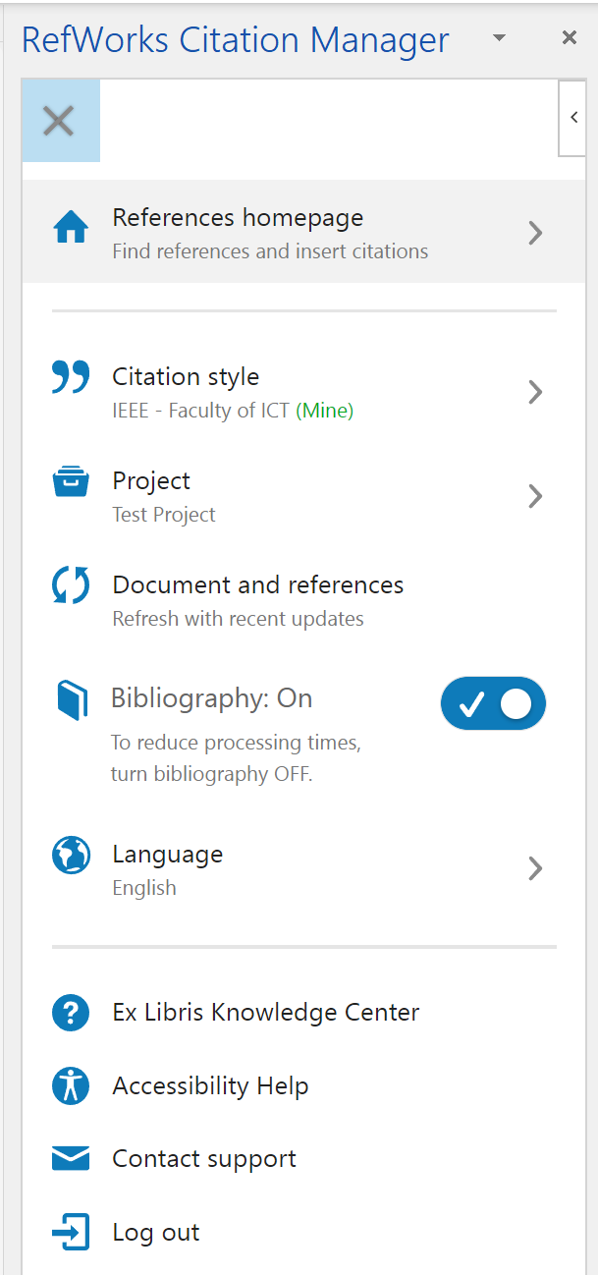
Figure 2.1 RefWorks Citation Manager settings options.
To insert a citation, go back to the References homepage in the RefWorks Citation Manager, then find the reference that you wish to cite, and as you hover over the citation, a Cite This button appears, as shown in Figure 2.2. Simply click this button and a citation is inserted at the current editing position in Word.
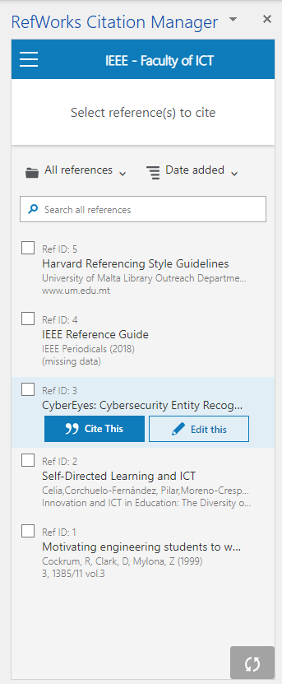
Figure 2.2 Inserting a citation using RefWorks.

Formatting the Reference Section
When the Bibliography setting is set to On in the RefWorks Citation Manager, the reference list is inserted at the end of the dissertation. However, this will not be in the correct format, nor in the correct position. To correctly format the Reference section, you need to first find this (in general this is placed at the end of the document). Then perform the following steps:
- Click anywhere in the reference list. This should make the Content Control box containing the references visible, as shown in Figure 2.3. In particular, on the top left-hand corner you should see three dots. Click on these dots. This selects the entire reference list.
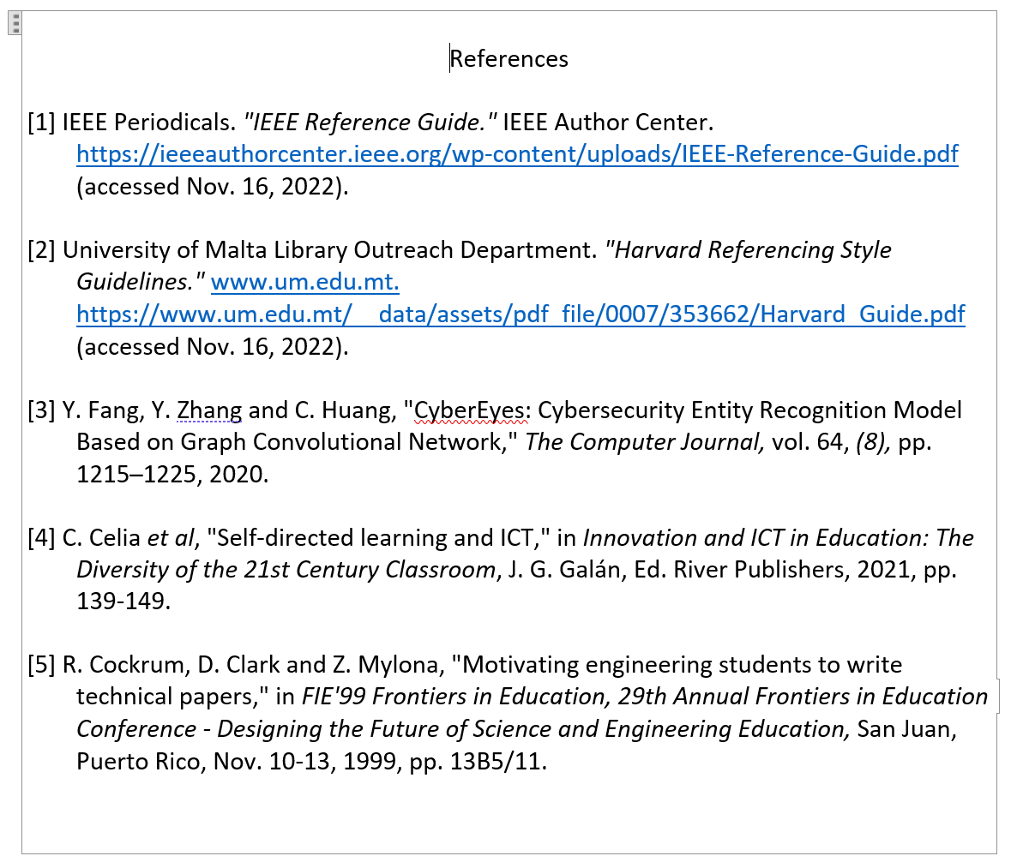
Figure 2.3 Content Control Box containing the references.
- Format the entire selection using the References style.
- If you are using the IEEE reference style, with the reference list still selected, go to the Home ribbon, and click on Replace in the Editing section. In the resultant dialog box, type in “] ” next to Find what (note the space after the square bracket) and “]^t” next to Replace with, as shown in Figure 2.4. Then hit Replace All. Do not continue the replace operation beyond the selected text.
- If you are using the Harvard reference style, then insert the title References at the start of the reference list. In the case of the IEEE style, this would be present already.
- Make sure that you have the complete reference list selected as indicated in step 1. Move the selected reference list to the correct position within the dissertation (if it is not already in that position). The easiest way to do this is to cut the selection and paste this in the correct position.
- Select the References title and apply the Heading style.
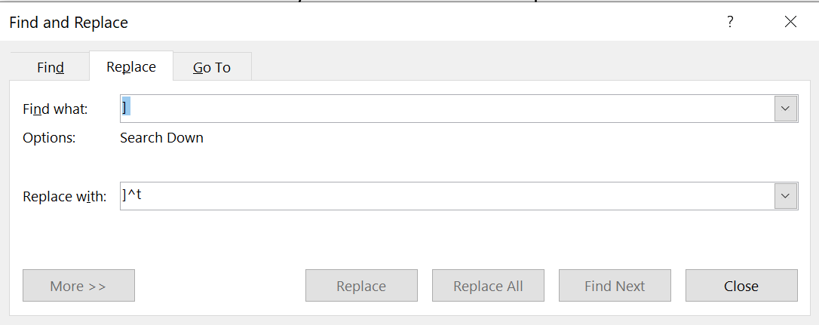
Figure 2.4 Correctly formatting the Reference section.
You need to perform the above steps every time that you switch on the Bibliograph switch in the RefWorks Citation Manager. It is therefore suggested that you either perform the above steps once you are done editing your dissertation, or else try to keep the Bibliography switch to On.
If you wish to automate the above process, you can include the macro given in Listing 2.1 and run this every time that you need to reformat the references section:
Listing 2.1 Macro to format references (Style: Code Listing).
Sub FormatReferences()
'
' FormatReferences Macro
'
'
ActiveDocument.SelectContentControlsByTag("rw.biblio").Item(1).Range.Select
Selection.Find.ClearFormatting
Selection.Find.Replacement.ClearFormatting
With Selection.Find
.Text = "] "
.Replacement.Text = "]^t"
.Forward = True
.Wrap = wdFindStop
.Format = False
.MatchCase = False
.MatchWholeWord = False
.MatchWildcards = False
.MatchSoundsLike = False
.MatchAllWordForms = False
End With
Selection.Find.Execute Replace:=wdReplaceAll
Selection.Style = ActiveDocument.Styles("References")

'The Harvard style does not have the References title included, so check for this
Selection.MoveUp Unit:=wdLine, Count:=1
Selection.MoveDown Unit:=wdLine, Count:=1
Selection.EndKey Unit:=wdLine, Extend:=wdExtend
If Left(Selection.Text, 10) <> "References" Then
' Check also one line up in case we've run this already
Selection.MoveUp Unit:=wdLine, Count:=1
Selection.EndKey Unit:=wdLine, Extend:=wdExtend
If Left(Selection.Text, 10) <> "References" Then
Selection.MoveDown Unit:=wdLine, Count:=1
Selection.HomeKey Unit:=wdLine
Selection.TypeParagraph
Selection.MoveUp Unit:=wdLine, Count:=1
Selection.TypeText Text:="References"
Else
Exit Sub
End If
End If
Selection.HomeKey Unit:=wdLine
Selection.Style = ActiveDocument.Styles("Headings")

End Sub
Note that the Code Listing style is applied to the above code segment.
If you are not familiar with Word macros, you can read how to install this by referring to https://support.microsoft.com/en-us/office/create-or-run-a-macro-c6b99036-905c-49a6-818a-dfb98b7c3c9c. In particular, refer to the section “Write a macro from scratch in Visual Basic.”

Examples of Different Types of References
When citing work that appeared in the literature, you need to consider the types of references that you can include. The most common types are conference [2], journal [5], book chapters [6], and online resources [3] citations, but there are other types. The referencing style guidelines found in [3], [4] define the different formatting styles for these types of references. It is therefore very important that you correctly label the reference type when you enter this into RefWorks. Detailed documentation on the proper use of RefWorks may be found at https://knowledge.exlibrisgroup.com/RefWorks.

Writing the Background and Literature Review Chapter
The purpose of the background section is to provide the reader with information that they cannot be expected to know but which they will need in order to fully understand and appreciate the rest of the project.
This section may describe such things as:
- the wider context of the project;
- the anticipated benefits of the system;
- the likely users of the system;
- any theory associated with the project;
- the software/hardware development method(s) used;
- any special diagramming conventions used;
- existing software (or hardware) that is relevant to the system;
- etc.
Since projects will likely include different kinds of theory, programming language choices, compilers, software/hardware components, APIs, development boards, IC technologies, one cannot always assume that the reader will be familiar with the details of all of them. The student should therefore explain concepts and use references to guide the reader.
The literature review component of the report should include:
- A study in the area of interested, highlighting the strengths and weaknesses of existing methods.
- A review of the state-of-the-art published material in the area.
- A critical analysis of exiting material and methods.
- An explanation showing why the literature chosen to review is relevant to the FYP.

Specification and Design

Further use of Captions
We have already seen the use of captions for figures and equations. Recall that this will allow automatic cross-referencing within Word. In addition to figures, you can also use captions to number and cross-reference other items in your dissertation.

Tables
Tables 3.1 and 3.2 show two example tables. Notice that in the case of tables, the table caption needs to be placed above the table and assigned the Caption Table style. Also note that Word does not allow inserting a cross-reference without using the caption label. This creates a problem when referencing more than one item (in this case, tables) at the same time, like we do at the start of this paragraph. In order to solve this problem, we need to manually edit the inserted cross-reference field as follows. Insert the cross-reference as normal (select References ribbon; click on Cross-reference; select Table under Reference type; select Only label and number under Insert reference to; select the table that you wish to refer to and then click Insert). This will create a cross-reference like Table 3.1. To remove the label and retain only the table number, click anywhere on this cross-reference and press SHIFT-F9 on your keyboard. This should reveal the field code used by Word to keep track of the cross-reference and should look something like { REF _Ref119834227 \h } (the label will be different in your case). To display just the cross-reference number, insert the text \# "0.0" after \h in the field code to make it look like { REF _Ref119834227 \h \# "0.0" }. With the cursor still somewhere in the field code press F9 on your keyboard. This should now display just the cross-reference number.
Table 3.1 Simple table example.
Header 1 | Header 2 | Header 3
1 | 2.3 | Orange
2 | 100.5 | Blue
3 | 35.0 | Black
Notice that the table header is applied the style Table Col Head, whereas the body of the table is applied the Table Body style. Sometimes you may need to modify these styles to adapt to the data being displayed. For example, in Table 3.1 the data in the second column contains numbers accurate to the first decimal point. To centre these properly in the column with the numbers aligned based on the position of the decimal point, you need to insert a decimal tab at the centre of the column and align the column to be left justified.
Table 3.2 shows a more complicated table example. Notice that the column sub-headers are assigned the style Table Col Subhead. Also note that even though the numbers under the third subheading are without a decimal point, they are still aligned on their virtual decimal point position as explained in the previous paragraph.
Table 3.2 A more complicated table example.
Table Head | Table Column Head
Table Head | Table column subhead 1 | Table column subhead 2 | Table column subhead 3
Item 1 | Item 2 | Item 3 | 100
Item 4 | Item 5 | Item 6 | 2
Item 7 | Item 8 | Item 9 | 10000
The paragraph immediately following a table should be assigned the Dissertation Body after Table style so as to maintain the correct spacing from the table.

Lemmas, Theorems, Corollaries etc.
You can also use captions to number lemmas, theorems, corollaries and other items. To define a new numbering sequence, you need to define a new caption label in Word. Unfortunately, these new caption labels are not stored with the document itself, so you would need to define these yourself, on a need to basis.
For example, to define a new caption for lemmas, select the References ribbon and then click on Insert Caption. This will open a similar dialog as the one shown on the left of Figure 1.2 on page 3. In the Insert Caption dialog box, create a new label by clicking the New label … button. Enter the label Lemma for this example (or any other item type, such as Theorem etc.) and press OK. Then click on the Numbering … button and in the resultant dialog box (similar to the one on the right-hand side of Figure 1.2) tick the Include chapter number checkbox and select the period for the number separator. Once you define the new caption label, you can start using it in the same way as for inserting captions for figures.
The inserted caption will be applied automatically the Caption style. Instead, manually apply the Labels style to the newly inserted caption as shown in the example below for Lemma 3.1. To put the label (Lemma in this case) and the number in bold, select these manually and apply the style Labels Bold. When inserting a cross-reference in this case, the cross-reference will also be shown in bold within the text and you have to manually remove this character formatting.
Lemma 3.1 The Earth is a sphere. (Style: Labels)
Note that Lemmas 3.1 and 3.2 will be used to prove Theorem 3.1.
Lemma 3.2 The Earth rotates around the sun.
If a cross-reference becomes bold again on updating, then edit the corresponding field code to include the switches “\* MERGEFORMAT” at the end of the field code.
Theorem 3.1 The Earth is one planet in the Solar System. (Style: Labels)
Proof: Using Lemmas 3.1 and 3.2 and observational data … (Style: Proof)
Note that the style for the Proof section is Proof, but you need to set the word Proof in italic by applying the style Proof Italic to it.
Captions for code listings may also be defined, as for Listing 3.1 shown below.
Listing 3.1 Example code (Style: Labels)
# include <stdio.h> //(Style: Code Listing)

int main()
{
return 0;
}
Captions for algorithms may also be defined, as shown for Algorithm 3.1 below. In the case of an algorithm, you need to convert the text to a table manually as sown in Algorithm 3.1. Note that the paragraph before an algorithm should have its After spacing set to 12 pt, as in this case. The Algorithm style used to write the algorithm proper automatically creates the line numbering.
Algorithm 3.1 Title of Algorithm (Style: Labels)
- inputs and outputs (Style: Algorithm)
- for i: 1 … k do

- …

Chapter Headers
In this template, automatic chapter headers appear on the top right-hand corner of each page. This enables easier navigation within the dissertation when reading it. In general, you do not need to change anything to make these work. However, if you insert new chapters, you must adhere to a couple of points not to break this feature.
When inserting a new Heading 1 style, the style is automatically setup to start on a new page. However, this is not enough to make the chapter headings work correctly. You also need to insert a Continuous Section Break before the new chapter title. You can do this by moving the cursor at the start of the new chapter title. Then from the Layout ribbon click on Breaks and then click Continuous under the Section Breaks. The headers are set to be different in the first section page compared to the rest of the section so that the chapter header does not appear on the first page of the chapter. The headers are also linked to previous headers, so that you will not need to insert any field codes in the headers yourself. Notice that section breaks are in general hidden. To view these and other control characters in Word you need to toggle these by pressing CTRL-SHIFT-8 on the keyboard. You can also access this option from the Home ribbon by clicking the pilcrow button in the Paragraph section.

Printing the Dissertation on Both Sides
This template is intended to create a dissertation that is printed only on one side of the paper (the left margin is wider than the right to allow for binding on the left). If you intend to print this dissertation on both sides of the paper, then you need to make some adjustments to facilitate this. It is highly recommended that you make a copy of the original document, just in case you may need to revert to the original single-sided version.
From the Layout ribbon, click on the corner arrow in the Page Setup section to open up the full range of page setup options and then select the Layout tab as shown in Figure 3.1. In the Section start drop-down box, select Continuous. In the Headers and footers section, tick the checkbox Different odd and even. In the Apply to drop-down box, select Whole document. Then click on the OK button. This correctly sets the gutter to be always on the inside of the page to enable correct binding.
You also need to correct the document’s headers and footers which are now different for odd and even numbered pages. Go to the Abstract page (page 2). You will notice that this now does not have page numbers. Double click in the footer area of this page, and you should enter the editor for the Header and Footer of the page. Over the footer area, you should see the label Even Page Footer – Section 1. From the Header & Footer ribbon, click on Next in the Navigation section. This should place you in the footer of the page labelled as Odd Page Footer – Section 1. Select the page number and copy and paste it in the previous Even Page Footer – Section 1 by clicking on the Previous button to navigate back to the previous section.
Now navigate to the header area labelled Even Page Header – Section 2. If you retained the original document layout, this should land you on the second page of the Introduction chapter. In the Header & Footer ribbon, make sure that the Link to Previous selection is unselected. Then, from the Insert ribbon, click on the Quick Parts button in the Text section and then click on Field. In the dialog box that opens, select StyleRef under Field names. Under Style names select Heading 1 and tick the check box next to Insert paragraph number. These selections are shown in Figure 3.2. Then press OK.
The above steps should insert the number 1 in the header (corresponding to chapter 1). Now, we need to insert the chapter title itself. Enter a space after the chapter number and then repeat the steps in the previous paragraph, but this time leave the Insert paragraph number checkbox unticked. This should insert the chapter title. The last step is to left-justify this header so that it always appears on the outside of the page.
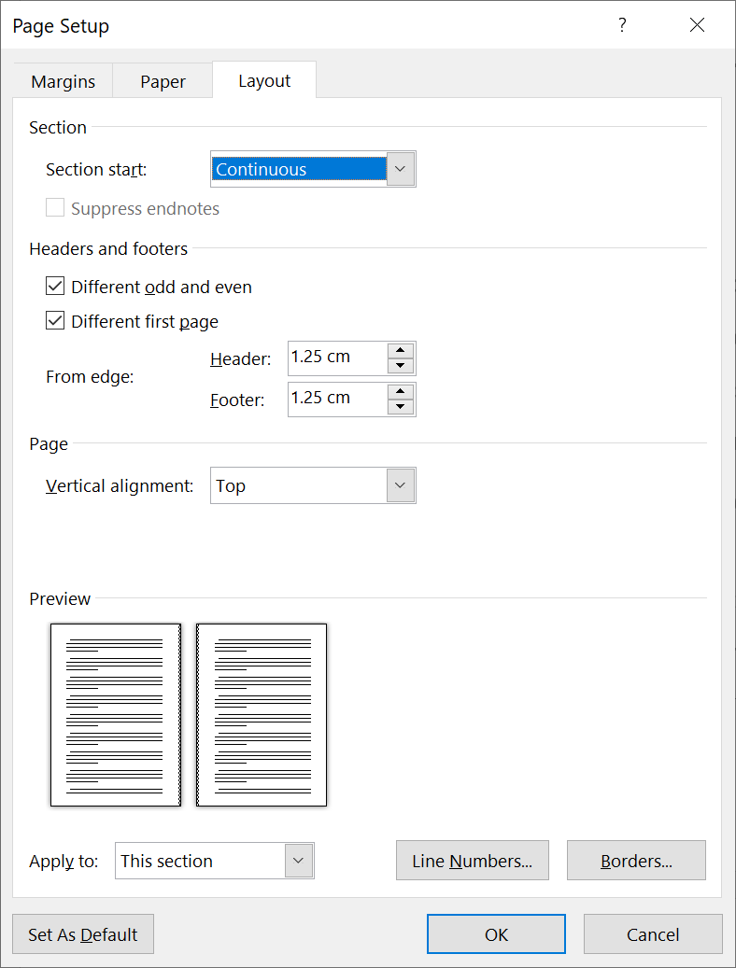
Figure 3.1 Converting document to printing on both sides.
You should also check the headers on other pages to make sure that everything appears correctly and to edit the headers as necessary.
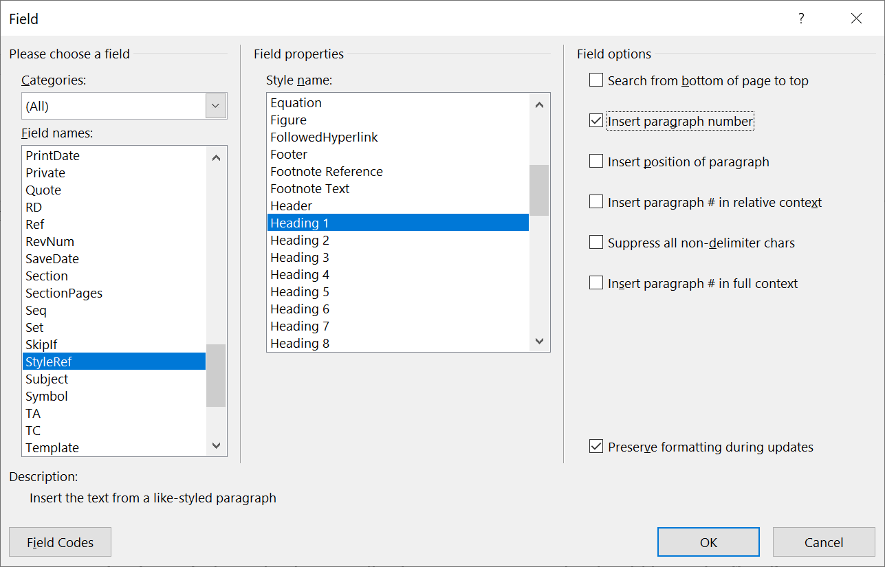
Figure 3.2 Inserting chapter headers.

Writing the Specification and Design Chapter
The purpose of this section is to give the reader a clear picture of the system/artifact/project/work that has been created in the FYP and why it has been created in the way chosen.
Details:
- Any design choices have to be justified (e.g., by discussing the implications of different design choices and then giving reasons for making the choices made).
- Fine details, specifically details of the system (software or hardware) should be left out. Also, any complete rigorous specification is better relegated to an appendix.
- Using diagrams (including but not limited to flowcharts and system level block diagrams) is strongly recommended.
- The design of the project will almost certainly have evolved during development. Focus should be made on the project as it is in its final state but often there are good reasons for describing intermediate states too (e.g., to discuss details of the design method used).

Implementation

Writing the Implementation Chapter
The Implementation section is similar to the Specification and Design section in that it describes the system but it does so at a finer level of detail, generally down to the code/theorem/algorithm/circuit/hardware… level. It can also describe any problems that may have arisen during implementation.
- In case of a software development describing of all the code in the system should be avoided as well as large “pieces” of code. Complete source code listings should be put on the accompanying digital media. In case of hardware the system should be divided into sub-systems or circuits that may be easily described and analysed.
- One must be especially critical to the operation of the system.
- Mentioning unforeseen problems encountered during implementation and how these are solved.

Testing and/or Evaluation

Writing the Evaluation and/or Evaluation Chapter
The testing and/or evaluation component of an FYP is critical.
- One has to make sure and explain why all tests used to evaluate the system are relevant, using evidence from the literature about similar systems, and justifying any deviations from standard approaches.
- Demonstration that system works as intended (or not, as the case may be).
- Include comprehensible summaries of the results of all critical tests that have been made.
- The student must also critically evaluate the system in the light of these tests results, describing its strengths and weaknesses.
- Ideas for improving it can be carried over into the Future Work section.
- Comparison of practical with theoretical results and their interpretation.
- Comparison with published work when available.

Future Work

Writing the Future Work Chapter
Whether by the end of the project all the original aims and objectives have been completed or not, there is always scope for future work. Also, the ideas will have evolved during the course of the project beyond the original target. The Future Work section is for expressing these ideas.

Conclusions

Writing the Conclusions Chapter
The Conclusions section should be a summary of the project and a restatement of its main results, i.e. what has been learnt and what it has achieved. An effective set of conclusions should not introduce new material. Instead, it should draw out, summarise, combine and reiterate the main points that have been made in the body of the report and present opinions based on them.
The Conclusions section marks the end of the report proper.
References
[1] Università ta' Malta. "Plagiarism and Collusion Guidelines for students, academics, and Faculties/Institutes/Centres/School." https://www.um.edu.mt/__data/assets/pdf_file/0007/436651/UniversityGuidelinesonPlagiarism.pdf. (accessed Nov. 22, 2022).
[2] R. Cockrum, D. Clark and Z. Mylona, "Motivating engineering students to write technical papers," in FIE'99 Frontiers in Education, 29th Annual Frontiers in Education Conference - Designing the Future of Science and Engineering Education, San Juan, Puerto Rico, Nov. 10-13, 1999, pp. 13B5/11.
[3] IEEE Periodicals. "IEEE Reference Guide." IEEE Author Center. https://ieeeauthorcenter.ieee.org/wp-content/uploads/IEEE-Reference-Guide.pdf (accessed Nov. 16, 2022).
[4] University of Malta Library Outreach Department. "Harvard Referencing Style Guidelines." www.um.edu.mt. https://www.um.edu.mt/__data/assets/pdf_file/0007/353662/Harvard_Guide.pdf (accessed Nov. 16, 2022).
[5] Y. Fang, Y. Zhang and C. Huang, "CyberEyes: Cybersecurity Entity Recognition Model Based on Graph Convolutional Network," The Computer Journal, vol. 64, (8), pp. 1215–1225, 2020.
[6] C. Celia et al, "Self-directed learning and ICT," in Innovation and ICT in Education: The Diversity of the 21st Century Classroom, J. G. Galán, Ed. River Publishers, 2021, pp. 139-149.

Bibliography
List here work that you have referred to during your work, but which you did not cite in the body of the dissertation. Same style and formatting rules as for references apply here (see Section 2.1.2). However, in the case of the IEEE style, there will be no citation numbers.

- When to Use Appendices (Style: Appendix Heading 1)
When inserting a new appendix use the Appendix Heading 1 style. The appendix numbering and the word “Appendix” are inserted automatically.
- Appendices Headings (Style: Appendix Heading 2)
When inserting appendix headings, use the corresponding Appendix Heading style according to the required level.
- Appendix Sub-Headings (Style: Appendix Heading 3)
Only three levels are defined for appendices.
- What to put in Appendices
Appendices are repositories for material which the student wishes to include in the report but which would seriously obstruct the flow of ideas put anywhere in the main body. Copies of the final version of any code should be avoided – the code must be available digitally on accompanying media.
Examples of items that could go in appendices are:
- A glossary of terms.
- Fundamental and basic theory.
- Schematic Diagrams and PCB/IC layout snap shots.
- Detailed notes on the programming language chosen or hardware platform used or technology used in an IC environment.
- A user’s guide.

- Version Information
Version Number: | 1.1
Date: | 30 November 2022
Version Information: | - Changed fonts to Lato.  - Given instructions how to install Lato font.  - Clarified location of IEEE – Faculty of ICT style.
Author: | Prof Inġ Victor Buttigieg
Version Number: | 1.0
Date: | 19 November 2022
Version Information: | First version of the FYP dissertation template.
Author: | Prof Inġ Victor Buttigieg
- Copyright Information
The copyright of this template belongs to the Faculty of Information and Communication Technology (ICT), University of Malta. Students of the Faculty of ICT are allowed to use this template to write their FYP dissertation. No part of this template is allowed to be used by other third parties without prior authorisation.
- Suggestions
If you have any suggestions how this template can be improved, or if you think that there is a specific issue with this template, please email these to victor.buttigieg@um.edu.mt.

You can select the entire table by clicking anywhere in the table and then clicking on the four arrows icon that appears in the top left-corner of the table.
Notice that cross-referencing was used to reference the step numbers here.
https://www.um.edu.mt/library/refworks
https://ieeexplore-ieee-org.ejournals.um.edu.mt/Xplore/home.jsp
When you are referencing a figure (or some other item) which is far away from the current position in the document, it is a good idea to include the page number where the item is located. You can do this using cross-referencing as well, by selecting Page Number under Insert reference to in the cross-reference dialog box.

