Consent Form

‘Consent’ means that you agree with everything that is written below.
If you agree with everything that is written, sign in the last part.

PHOTOGRAPH OF RESEARCHER | I would like to apply to take part in the project that [NAME OF RESEARCHER] is doing.
USE SAME PICTURE AS INFORMATION LETTER THAT REFLECTS THE THEME OF THE STUDY | I have information about the study and had the chance to ask questions and get a reply.
 | I know that I will be interviewed / take part in a group meeting / [STATE OTHER RESEARCH METHOD].
 | I know that the interview / group meeting / [OTHER RESEARCH METHOD] will be one hour long [OR STATE OTHER DURATION].
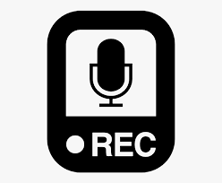 | I know that [NAME OF RESEARCHER] will record the interview/focus group on audio. I also know that only [NAME OF RESEARCHER] and the supervisor will be able to listen to the recordings. After the study is finished, [NAME OF RESEARCHER] will destroy the recordings. [THIS CAN BE ADAPTED ACCORDING TO THE RECORDING METHOD USED]
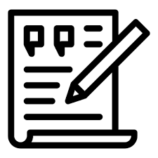 | I know that after we do the interview, I will have a copy of what I said so that I can see if I want to change, add or remove anything. If I want, I can also check what I said with someone I trust to make sure that it’s okay. [THIS CAN BE ADAPTED ACCORDING TO THE RESEARCH METHOD USED AND THE MECHANISM PUT IN PLACE TO CHECK THE DATA WITH PARTICIPANTS]
 | I know that when [NAME OF RESEARCHER] writes about the study, he/she will use parts of what I said but will not use my real name. However, there can be a chance that someone reads the study, they may recognize me.
 | I know that I do not have to take part in this project if I do not want to. If I take part and I want to stop, it will not be a problem. I can stop any time. I do not have to give reasons for stopping.
 | I know that [NAME OF RESEARCHER] will act according to what Maltese law says about how to store information about me. This means that the information will be in a secure place. [NAME OF RESEARCHER] will also destroy all the information from the interviews, including recordings, after the study is finished [MONTH, YEAR].
 | I know that if I take part, I will have a chance to talk about what is important to me about [RESEARCH TOPIC]. I will also be helping others learn more about what is important for persons with intellectual disability. [THIS CAN BE ADAPTED ACCORDING TO THE BENEFITS ENVISAGED FOR PARTICIPANTS]
 | I know that there should not be a problem if I take part. But if something happens that upsets me, I can talk about it so that the problem is sorted. If I need to speak to someone else, I will be helped to do this. I will not have to pay anything for the help I receive.
 | I have receive the information letter about the study and I will also have a copy of this consent form.

I have understood everything that is written here and if I had any questions they have been answered. I would like to take part in this study.

Name and surname: _______________________________________

Signature: _______________________________________

Date: ________________________________________

