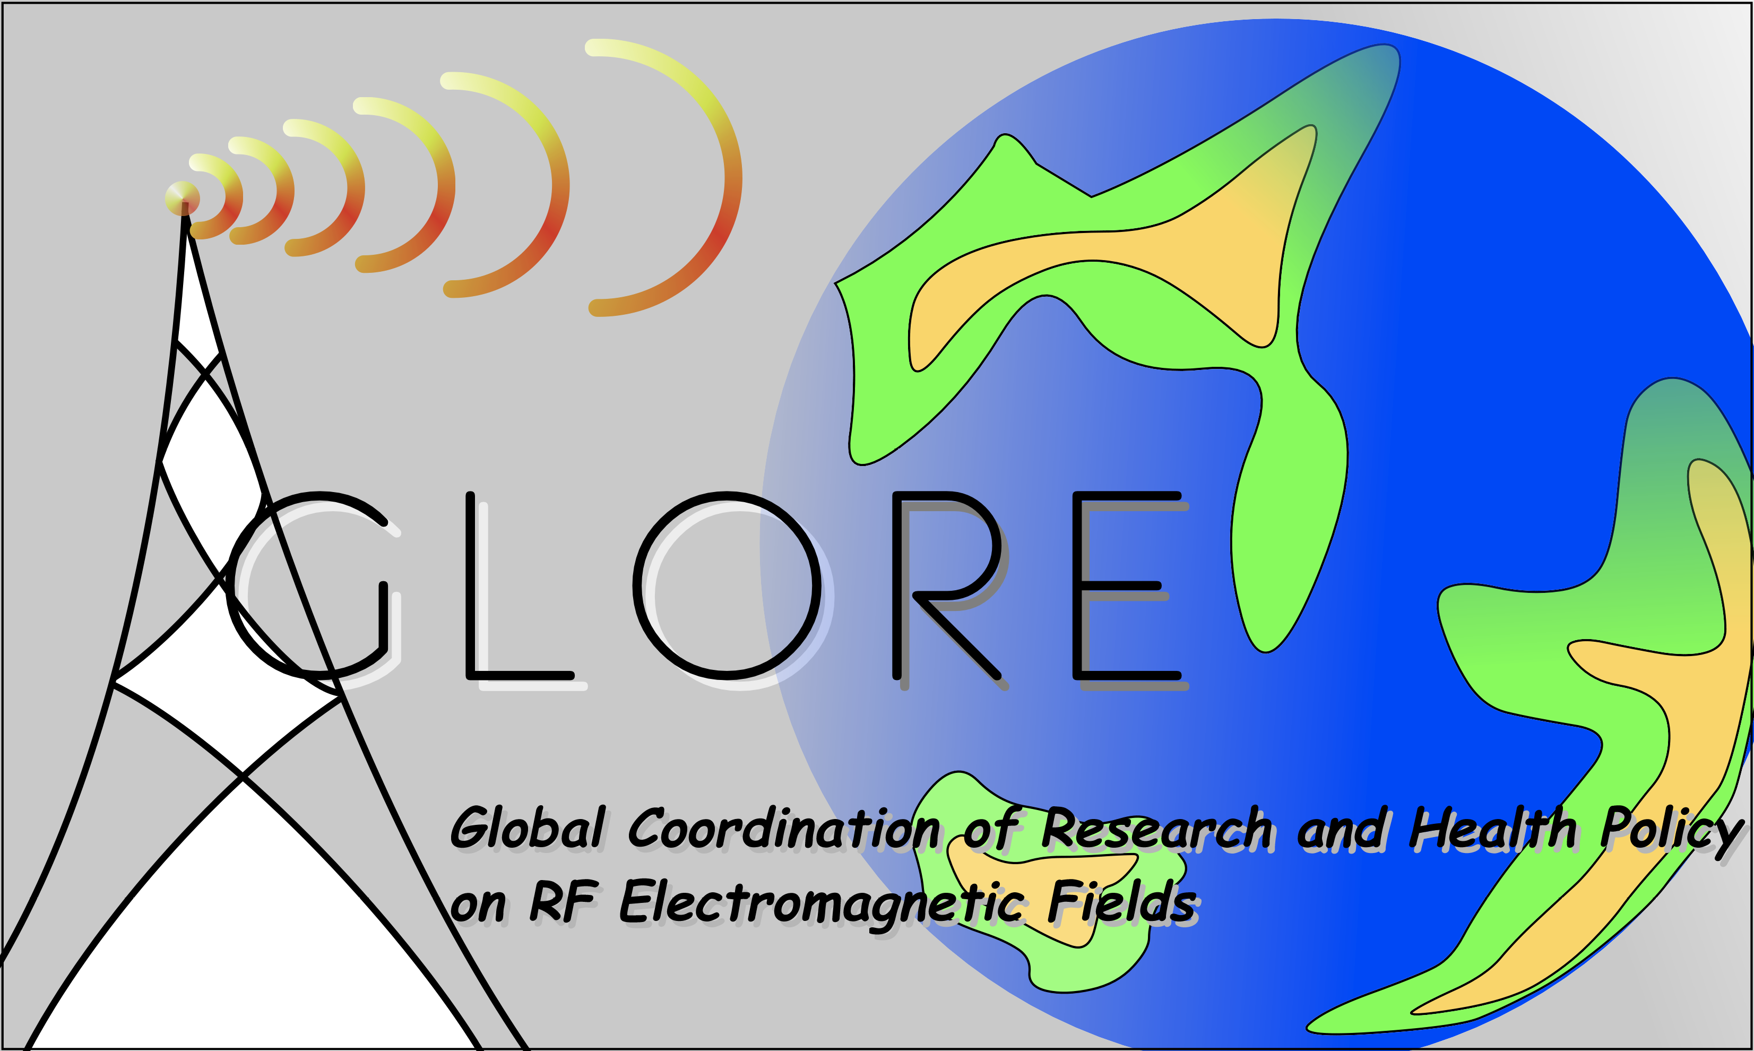 | GLORE 2018 Annual Meeting  Paris  November 12-13, 2018

Venue: Telecom ParisTech, LTCI, Chaire C2M
Organized by: Telecom ParisTech, LTCI, Chaire C2M, URSI K France and CNR Italy

The 22nd Glore meeting is hosted by European countries on 12th and 13rd of November. Glore2018 gives the opportunity to present and discuss the research activities and the processes of health risk management and of risk communication, on the possible effects of the electromagnetic fields (EMF) on health. Each year scientists and policy authorities from GLORE delegations take part in this discussion. GLORE (Global Coordination of RF Communications on Research and Health Policy) is a coordination action initiated by Japan and Korea and joined by Europe and then by USA, Australia and Canada.
This year Glore involves the delegations of Japan, Korea, Europe, USA, Australia, Canada Peru and Thailand

Draft Program
November 12, 2018 – Open to observers
09:00 – 9:45 | Registration and welcome coffee
9:45-10:00 | Introduction
S1 | EMF & Health effects ChairPerson:
10:00 – 10:25 | Bioeffect research in Korea. N Kim, Chungbuk National University, Korea
10:25 - 10:50 | Bioeffect research in Japan. Chiyoji Ohkubo, Japan EMF Information Center
10:50 – 11:15 | Dosimetry research relevant to bio medical and health studies in Japan. Kanako Wake, NICT, Japan
11:15 – 11:40 | The experience of Cost Action MyWAve Laura Farina Galway Univ, Ireland
11:40 – 12:05 | Cost Action EMF MED and SKIN-RF project György Thuróczy NRIRR Hungary
12:05 - 12:30 | Latin American review update on radiofrequency telecomunications: new developments measurements and human health. Victor Cruz Orneta, Perù
12:30– 12:45 | Issue of RF fields and health in Thailand Mr. Takorn Tantasith, Secretary-General of NBTC, Thailand
12:45 – 14:00 | Lunch
S1 - reprise | EMF & Health effects ChairPerson:
14:00 – 14:25 | ANSES position TBC
14:25 – 14:50 | WHO TBC
14:50 – 15:15 | INCIRP Position. Rodney Croft, Australia
15:15 – 15:45 | Open discussion
15:45 – 16:10 | Coffee Break
S2 | New challenges linked to 5G exposure assessment ChairPerson:
16:10 – 16:35 | Measurement method of EMF Human body exposure for 5G mobile phone. DG Choi, RRA, Korea
16:35 – 17:00 | EMF measurement and analysis of beamforming radiation for 5G NR FR1 base station. SW Moon, AGOS, Korea
17:00 – 17:25 | Evaluation method of EMF Human body exposure above 6GHz. Soichi Watanabe, NICT, Japan
17:25 – 17:50 | Standardization of power density measurement in millimeter wave 5G wireless communication. T. Onishi, Japan (Convenor, IEC TC106 JWG12)
17:50 – 18: 15 | The USA position. Martin Doczkat, USA
18:15 – 18:45 | Open discussion
19:00 | Cocktail & Dinner

November 13, 2018 – Close to delegates
S3 | Considerations on NTP study ChairPerson:
08:45 – 09:10 | NTP Study: the Korea view. Y Ahn, Ajou University School of Medicine, Korea
09:10 – 09:35 | NTP Study: the Japan view. Preliminary evaluation of SAR and temperature rise of rats exposed to reverberation chamber: J Wang, Nagoya Institute of Technology, Japan
09:35 – 10:10 | Effect on the body temperature change of rat during RF exposure in the reverberation chamber. S Jeon, ETRI, Korea
10:10 – 10:35 | NTP Study: the USA view. M Wyde TBC
10:35-11:00 | Open discussion on S3
11:00 – 11:20 | Coffee Break
S4 | Epidemiological Studies ChairPerson:
11:20 – 11:45 | The Geronimo and Mobi-kids European Projects. Elisabeth Cardis, IS Global Spain
11:45 – 12:10 | Mobile phone use and brain tumour trends in Australia. Ken Karipidis, Australia
12:10 – 12:35 | Epidemiological studies: the view of IARC. Isabelle Daltour, IARC
12:35 – 12:50 | Open discussion on S4 Sessions
13:50 – 14:00 | Lunch
S5 | Regulation and limits in view of 5G ChairPerson:
14:00 – 14:20 | Regulation in Japan for 5G Yutaka Sekiguchi, Ministry of Internal Affairs and Communications, Japan
14:20 – 14:40 | Regulation In France Jean Benoit Agnani, ANFr, France
14:40 – 15:00 | Regulation In US Martin Doczkat, FCC USA
15:00 – 16:30 | Round table
Rodney Croft, ICNIRP,
J Wiart Chair of TC 106x CENELEC,
Jean Benoit Agnani, ANFr
Akimasa HIrata , Nagoya Institute of Technology, Japan
Yutaka Sekiguchi, Ministry of Internal Affairs and Communications, Japan
Martin Doczkat, FCC USA
xx Korea

16:30 – 17:00 | Conclusions

