İstanbul Airport
From İstanbul Airport to 4. Levent:
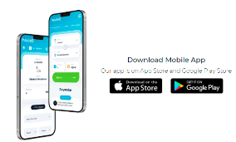
https://www.hava.ist/en/Home/Index
You can download the app to purchase the ticket and check the timetable.
You can pay inside the bus with credit card or cash.
Route;
Departure: İstanbul Airpot-4.Levent- Zincirlikuyu Metrobüs-Beşiktaş Meydan
Return: Beşiktaş Meydan-Zincirlikuyu Metrobüs-4.Levent-İstanbul Havalimanı
Ticket Price: ₺ 44,00
There are different stations also you can find from the webpage and applications

Sabiha Gökçen Airport
From Sabiha Gökçen to Taksim:
https://www.havabus.com/yolcuservisi/taksim-sabihagokcenhavalimani.aspx
Departure Point in Taksim: Gezi Parkı Metro Çıkışı
Open address: Gümüşsuyu Mah. Cumhuriyet Cad. Gezi Parkı Metro Çıkışı Taksim / İstanbul
It takes approximately 1.5 hours and this period may vary according to the traffic density.
Route;
Departure: Sabiha Gökçen Airport -Kavacık-FSM Bridge-1.Levent-Zincirlikuyu Metrobus- Dolapdere-Taksim
Return: Taksim-Beşiktaş- Bosphorus Bridge -Tem Access Road-Sabiha Gökçen Airport
Ticket Price: ₺ 52,50
You pay inside the bus with credit card.

Transportation
IstanbulKart Mobile
There is a mobile app for the Istanbulkart, where you can use and load credits online. You can find by searching “istanbulkart” on AppStore or Google Play. You can find more information on https://www.belbim.istanbul/

How to obtain Istanbulkart from the Istanbul Airport?
You can purchase the Istanbulkart upon your arrival to the Istanbul Airport (IST), from the 24 yellow/blue machines located at the -2 arrivals floor, or from the Havaist (airport shuttle) counters located along the exits, or the authorized exchange offices. We recommend to obtain your Istanbulkart upon your arrival to the airport, because you’ll need to use it on the public buses for getting to the city center. You can not pay cash to the shuttles or public buses.
How to reach İstanbul Technical University
As shown the metroline map, green line (M2) has İTÜ Ayazağa station.
Metro station

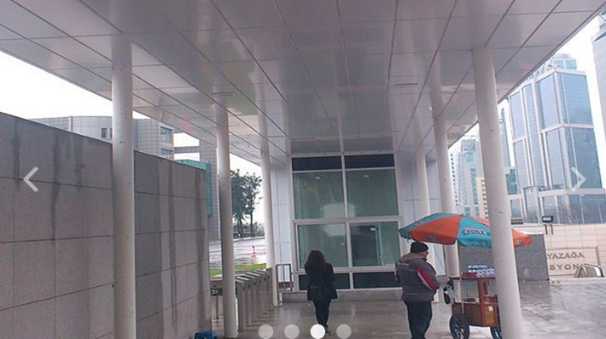
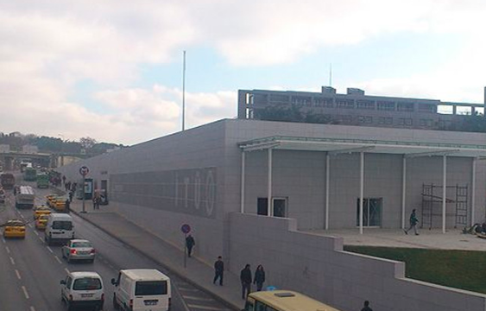
ITU-main entrance
ITU campus
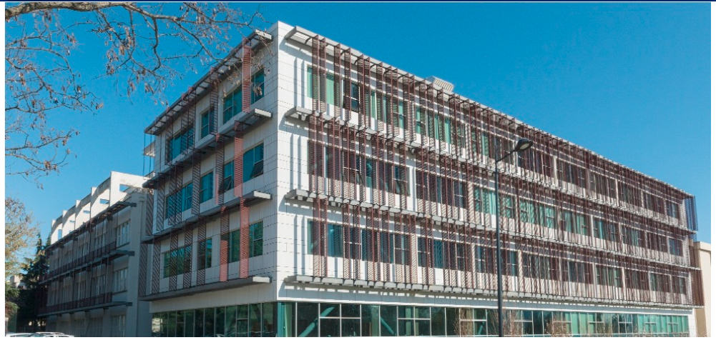
Electrical and Electronics Engineering
